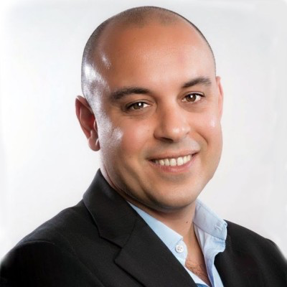
Title: Gonçalo Borrêga, VP of Product Management, AI & AppDev
OutSystems

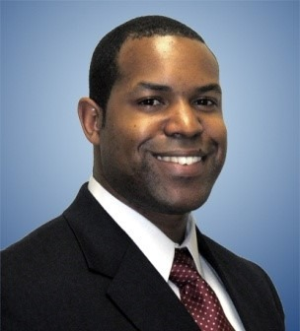
Title: Michael Harper, Managing Director, KPMG

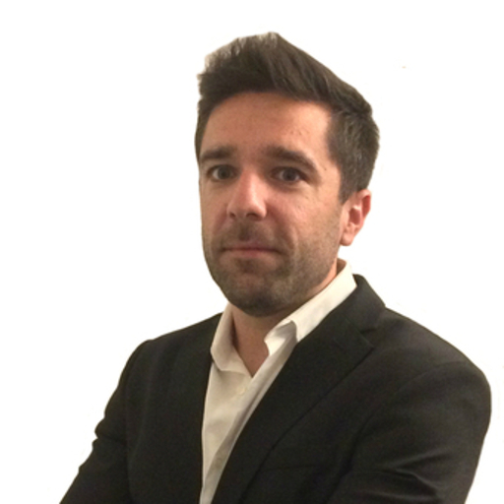
Title: Fernando Santos, Principal Product Marketing Manager, OutSystems

